**PROGRAMS**

**Write a program to check the given number is positive.**

import java.util.Scanner;

class PositiveNumberChecker {

public static void main(String[] args) {

Scanner scanner = new Scanner(System.in);

System.out.print("Enter a number: ");

double number = scanner.nextDouble();

if (number > 0) {

System.out.println("The number " + number + " is positive.");

} else if (number < 0) {

System.out.println("The number " + number + " is negative.");

} else {

System.out.println("The number is zero.");

}

}

)

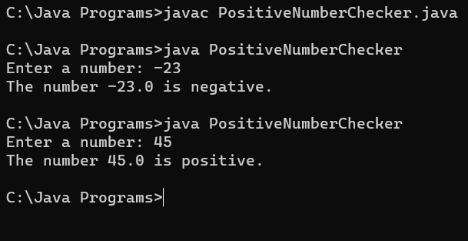

**Write a program to check whether the candidate is eligible for driving license.**

import java.util.Scanner;

class DrivingLicenseEligibilityChecker {

public static void main(String[] args) {

Scanner scanner = new Scanner(System.in);

System.out.print("Enter your age: ");

int age = scanner.nextInt();

int minimumDrivingAge = 18;

if (age >= minimumDrivingAge) {

System.out.println("Congratulations! You are eligible for a driving license.");

} else {

System.out.println("Sorry, you are not eligible for a driving license.");

}

}

}

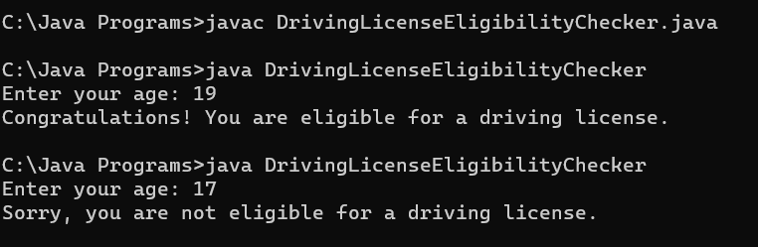

**Write a program to check whether the given number is Odd/Even.**

import java.util.Scanner;

class OddEvenChecker {

public static void main(String[] args) {

Scanner scanner = new Scanner(System.in);

System.out.print("Enter a number: ");

int number = scanner.nextInt();

if (number % 2 == 0) {

System.out.println("The number " + number + " is even.");

} else {

System.out.println("The number " + number + " is odd.");

}

}

}

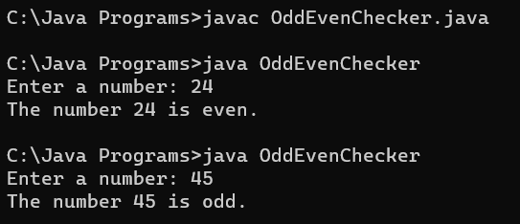

**Write a program to find largest of three Numbers.**

import java.util.Scanner;

class LargestOfThreeNumbers {

public static void main(String[] args) {

Scanner scanner = new Scanner(System.in);

System.out.print("Enter the first number: ");

double num1 = scanner.nextDouble();

System.out.print("Enter the second number: ");

double num2 = scanner.nextDouble();

System.out.print("Enter the third number: ");

double num3 = scanner.nextDouble();

double largest = num1;

if (num2 > largest) {

largest = num2;

}

if (num3 > largest) {

largest = num3;

}

System.out.println("The largest number is: " + largest);

}

}

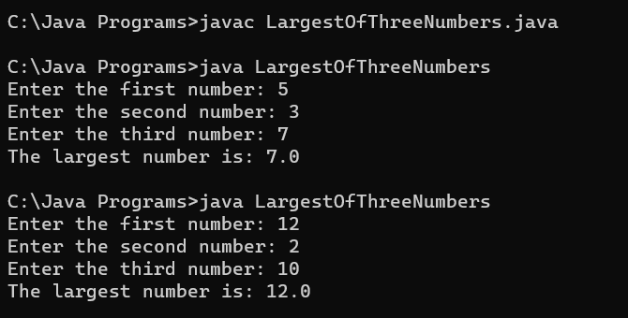

**Write a program to find the grade of a Student based on total marks**.

**•** **Mark less than 40- Failed**

**• 40 to 60–Grade D**

**• 61 to 70-Grade C**

**• 71 to 80-Grade B**

**• 81 to 100-Grade A**

import java.util.Scanner;

class StudentGradeCalculator {

public static void main(String[] args) {

Scanner scanner = new Scanner(System.in);

System.out.print("Enter the total marks: ");

int totalMarks = scanner.nextInt();

char grade;

if (totalMarks < 0 || totalMarks > 100) {

grade = 'I';

} else if (totalMarks < 40) {

grade = 'F';

} else if (totalMarks <= 60) {

grade = 'D';

} else if (totalMarks <= 70) {

grade = 'C';

} else if (totalMarks <= 80) {

grade = 'B';

} else {

grade = 'A';

}

if (grade == 'I') {

System.out.println("Invalid total marks. Please enter a value between 0 and 100.");

} else {

System.out.println("Grade: " + grade);

}

}

}

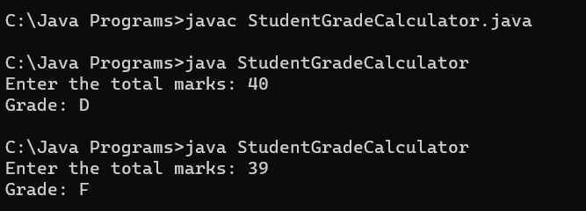

**Write a program to check whether the given character is Vowel/not (Use switch-case).**

import java.util.Scanner;

class VowelChecker {

public static void main(String[] args) {

Scanner scanner = new Scanner(System.in);

System.out.print("Enter a character: ");

char character = scanner.next().charAt(0);

character = Character.toLowerCase(character);

switch (character) {

case 'a':

case 'e':

case 'i':

case 'o':

case 'u':

System.out.println(character + " is a vowel.");

break;

default:

System.out.println(character + " is not a vowel.");

}

}

}

